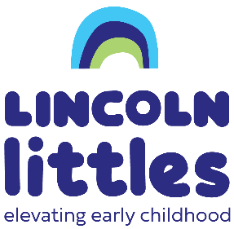
Covid-19 Early Childhood Funds
Helping You Help Families
Lincoln Littles has partnered with the City of Lincoln to offer tuition assistance for families impacted by Covid-19. This opportunity is available not only to already approved Lincoln Littles providers but for the entire Lincoln community of licensed family home and child care center providers! Child Care providers must be enrolled in Step Up to Quality, willing to accept subsidy, and offer full-year, full-day child care. These funds can be used for past due balances created during the pandemic or for a family experiencing any of the following:
- a reduction in salary as a result of the coronavirus
- reduced hours as a result of the coronavirus
- been furloughed as a result of the coronavirus
- been laid off as a result of the coronavirus
- been terminated as a result of the coronavirus
- been placed in alternate shelter as a result of health and safety, either self-isolation due to symptoms or to decrease shelter population as a result of coronavirus
- Experiencing homelessness (in shelter or unsheltered/place not meant for human habitation) and in need of assistance for the health and wellbeing of myself and others as a result of coronavirus.
- loss of income due to contracting or a family member contracting or being isolated after exposure to Covid-19

Qualifying families apply to their provider for funds to be paid directly to child care providers through December 2021 (unless the funding runs out prior to 12/2021) (see family application for income requirements).
Qualifying families must complete the Lincoln Littles Covid-19 Family Application and Declaration of Covid-19 form along with all supporting documentation.
Child Care Providers will submit the Family Application, Covid-19 Declaration, and supporting documentation with a Request for Payment form to Lincoln Littles email at Suzanne.schneider@lincolnlittles.org

Process for Providers to Apply for This Funding
- Child Care providers will apply for funds to cover Covid-19 impacted child care expenses through Lincoln Littles.
- Child Care providers must be licensed and enrolled in Step Up to Quality to be eligible.
- Families must complete the Lincoln Littles Family Application, supporting documentation and Covid-19 Declaration form with the child care provider.
- Child care providers will submit the Covid-19 declaration, family application, supporting documents and billing form to Lincoln Littles. Email to Suzanne.schneider@lincolnlittles.org
- Payments will be made directly to child care providers (Checks will come from the Lincoln Community Foundation).

Lincoln Littles
Suzanne Schneider
Suzanne.schneider@lincolnlittles.org
(402) 617-7470

